**Exercise 3.1: Quadratic Equations**

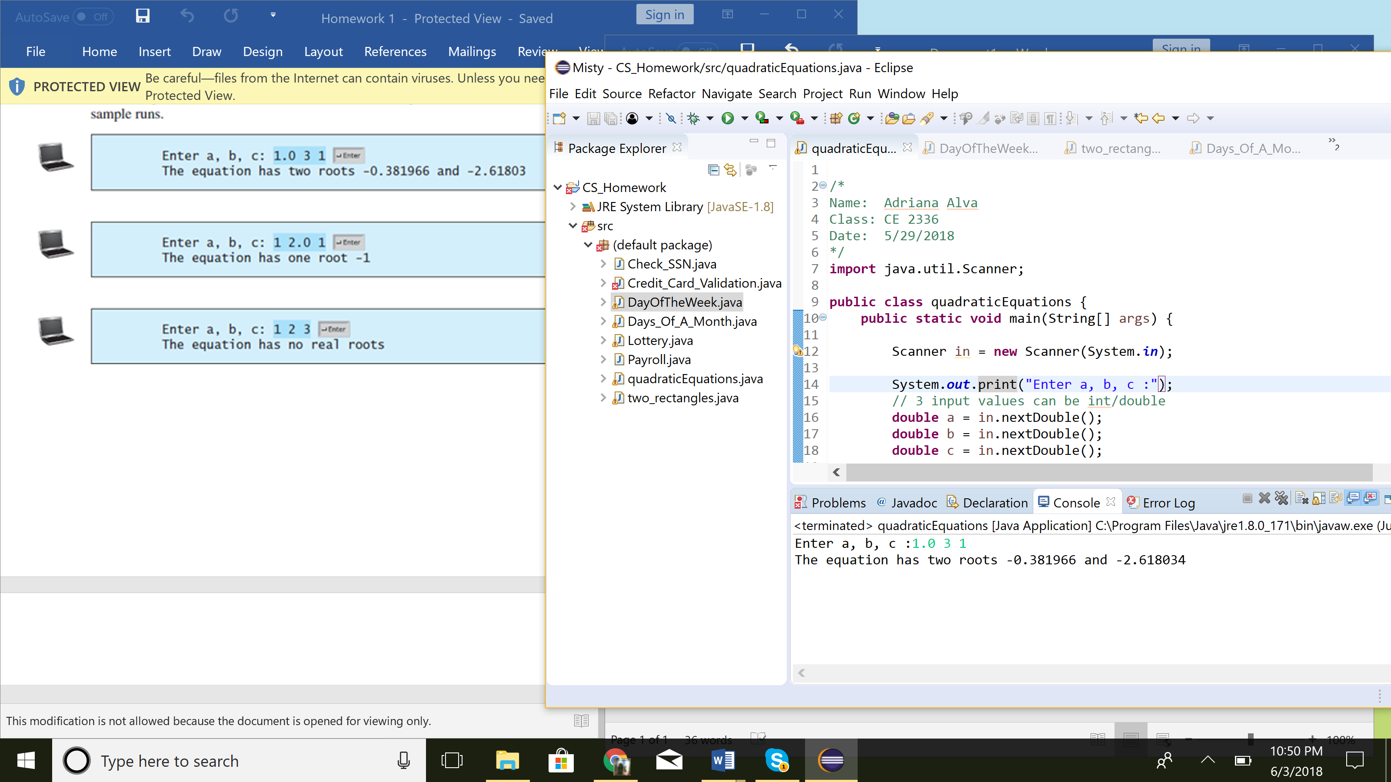

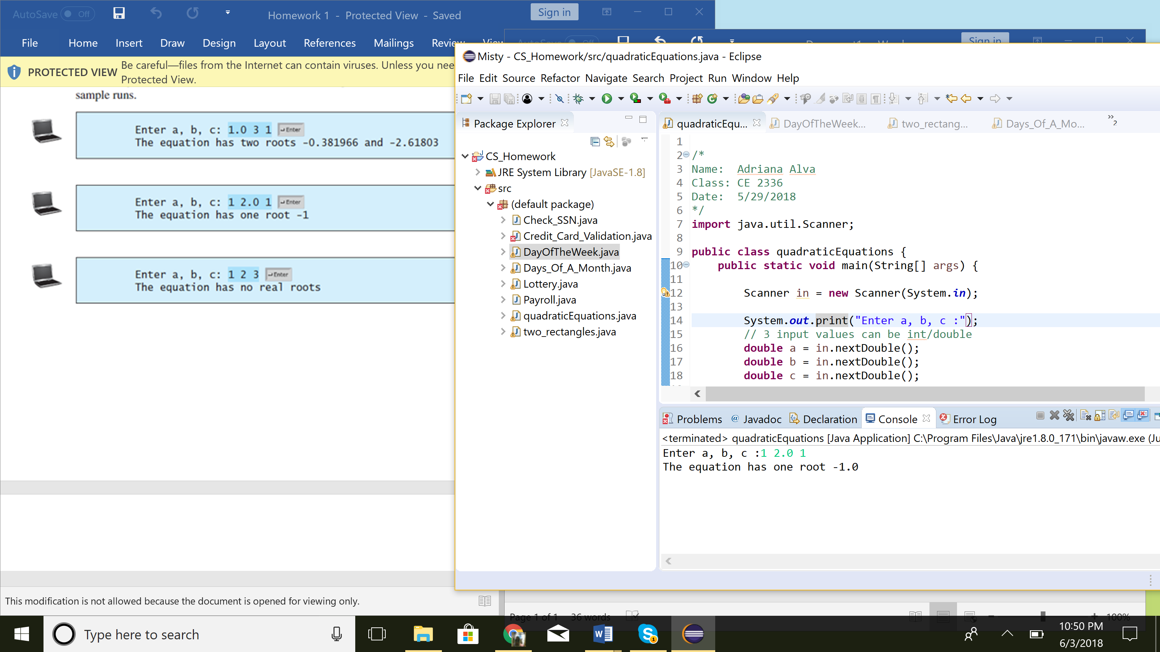

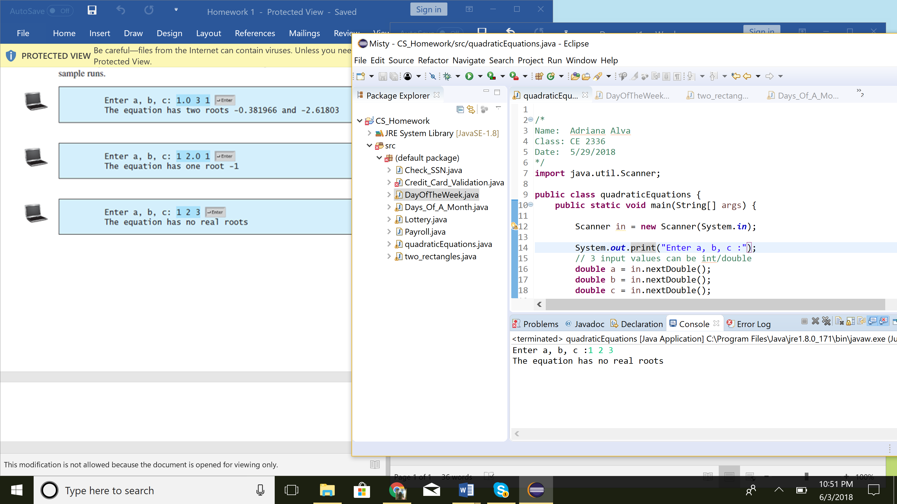

1. Prompt user for input of values a,b,c
2. Use formula given to solve for discriminant
3. the equation has two roots -0.367895 and 2.345678   printf("The equation has two roots %.6f and %.6f", r1, r2);
   1. Check discriminant to see if it is…
      1. > 0 : 2 roots
      2. = 0 : 1 root
      3. < 0 : 0 roots
4. Display results

**Exercise 3.15: Lottery**

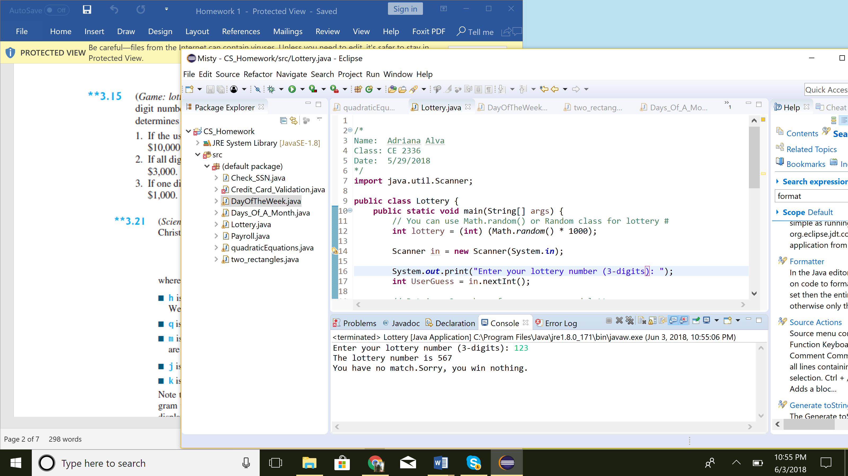

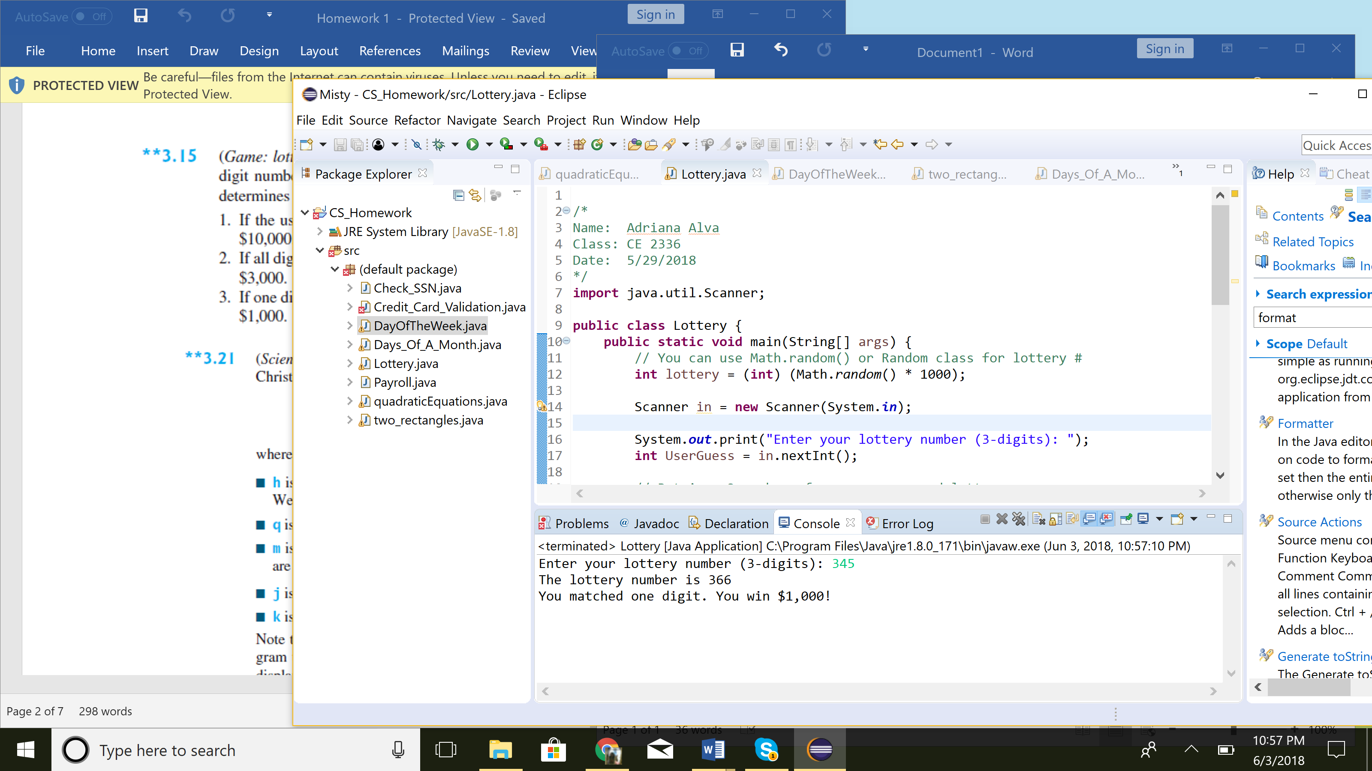

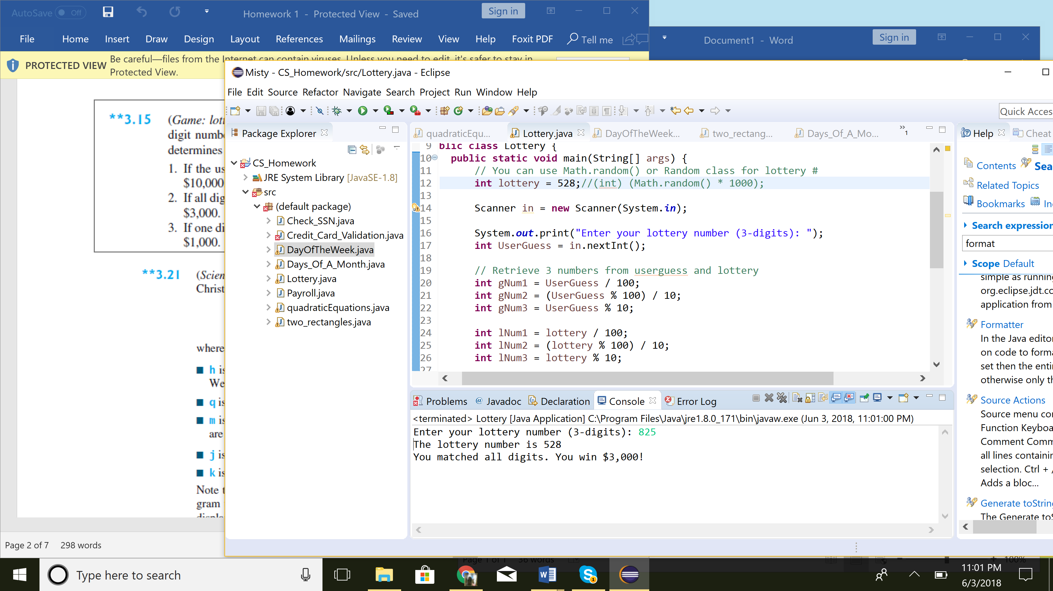

1. Revision of listing 3.8 lottery.java
2. Prompt user for a 3 digit guess for the lottery
3. Program must determine if they won the lottery
   1. Use if/elseif to check for:
      1. Case 1: they match the lottery numbers in exact order: $10,000
      2. Case 2: they match all digits, but not in order: $3,000
      3. Case 3: they match 1 digit : $ 1,000
      4. Case 4 : they matched nothing: lost
4. Print out the result of their lot # input based off of the cases

**Exercise 3.21: Day of the Week**

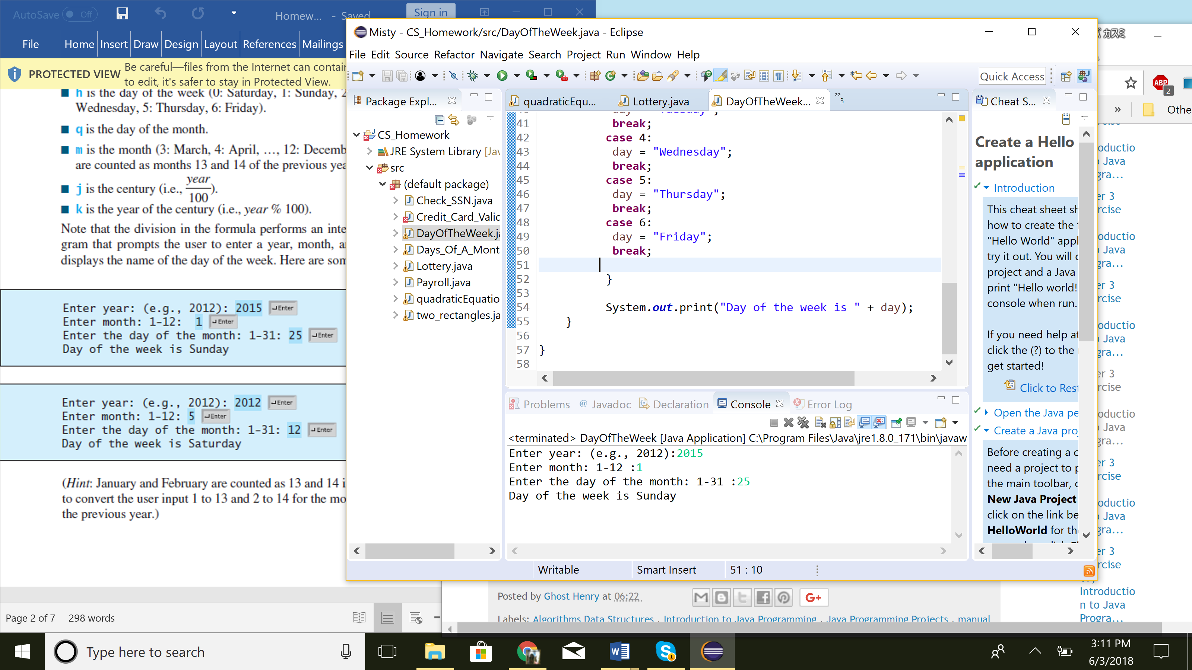

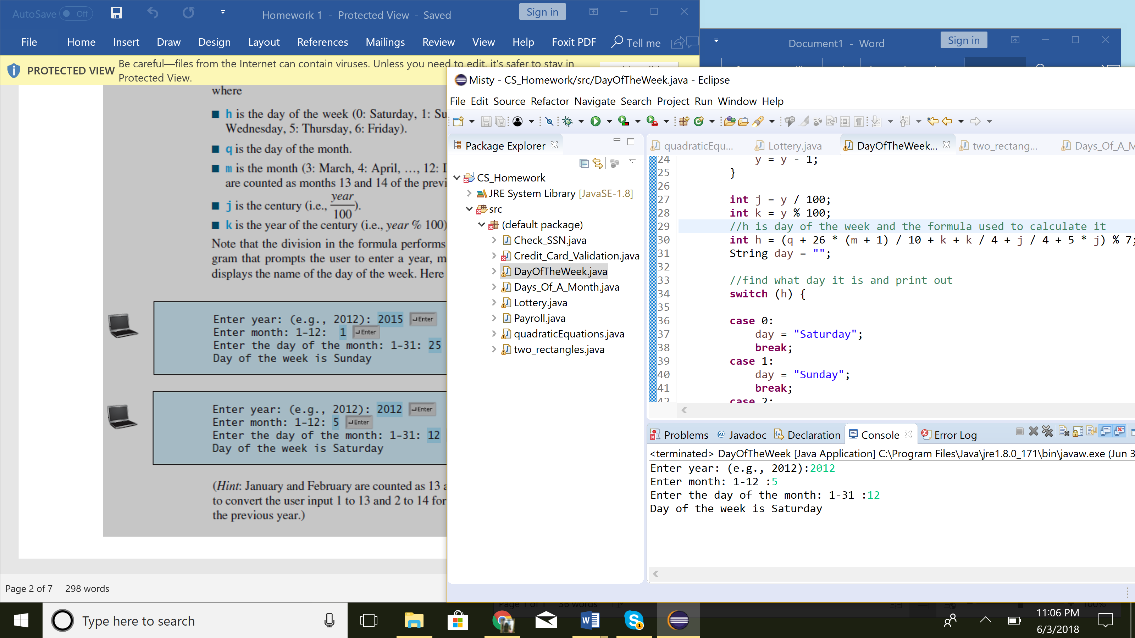

1. Prompt user to enter year,month, and day of the year
   1. H is the day of the week
   2. Q is the day of the month
   3. M is the month
   4. J is the century
   5. K is the year of the century
2. Use the formula provide for h
3. To know what day it is, use a switch for h to make it easier to read.
4. Display day of the week

**Exercise 3.28: Two rectangles**

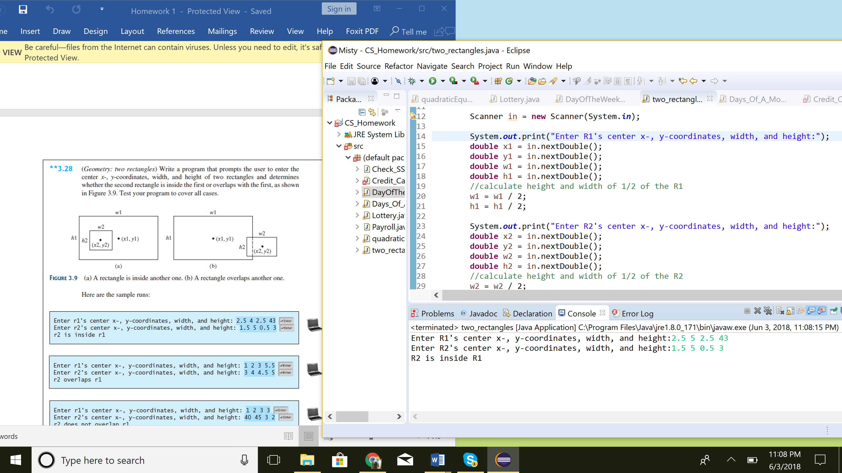

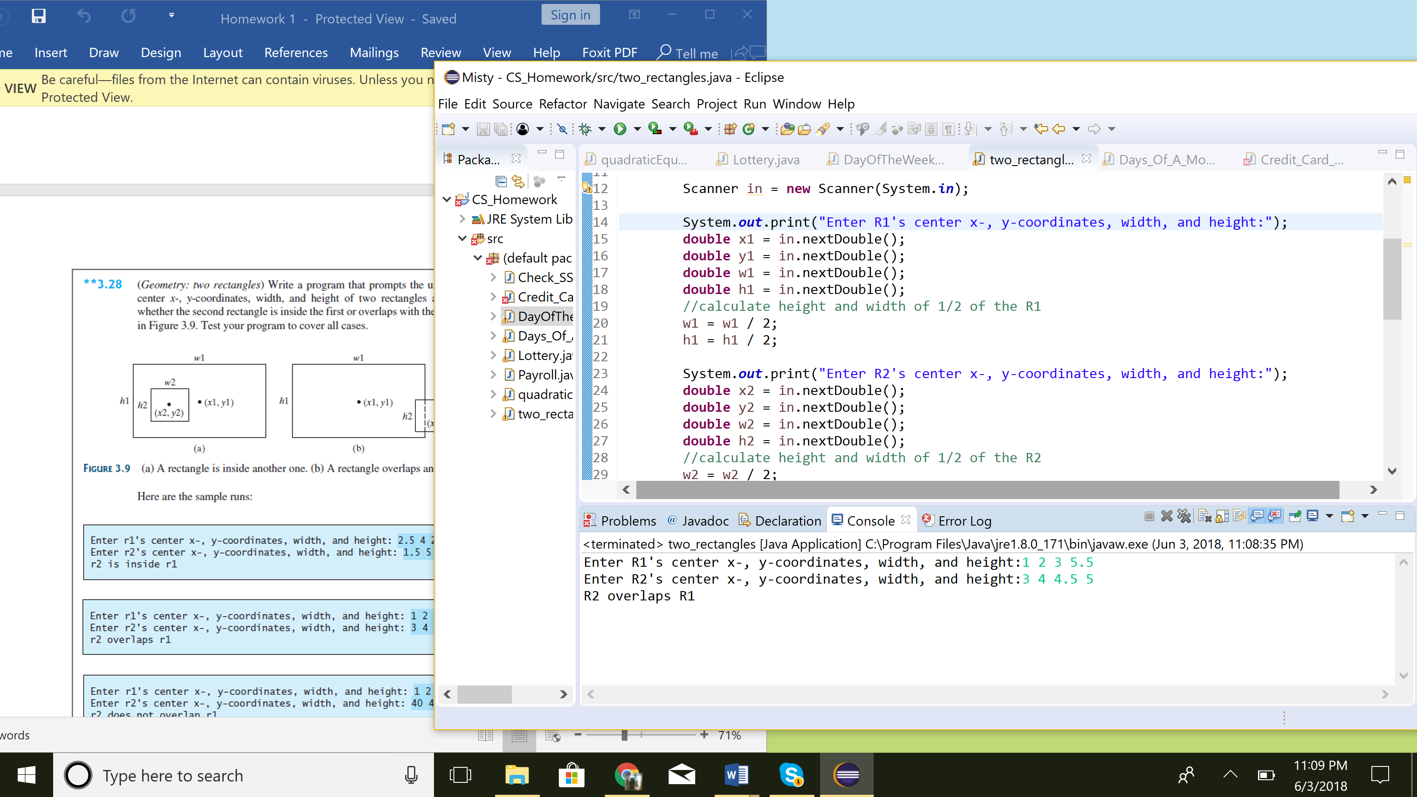

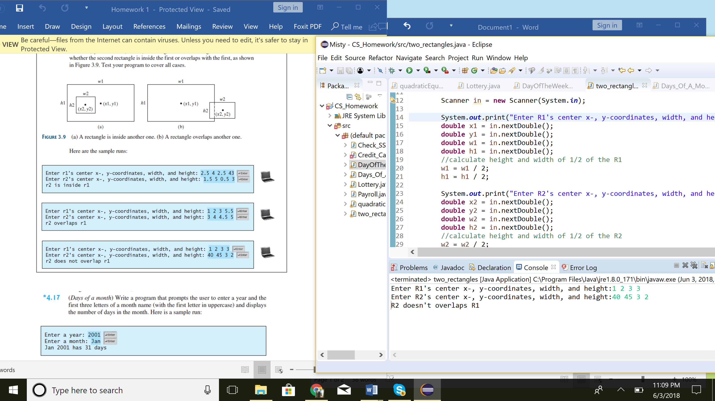

1. Prompt user for input of x,y coordinates, width and height
2. Calculate height and width of half of R2
   1. Then calculate r1, r2 points
3. Check for different cases:
   1. Case 1 : R1 and R2 are inside on another
   2. Case 2 : R1 and R2 overlap
   3. Case 3 : R1 and R2 do not overlap
4. Print out results

**Exercise 4.17: Days of the Month**

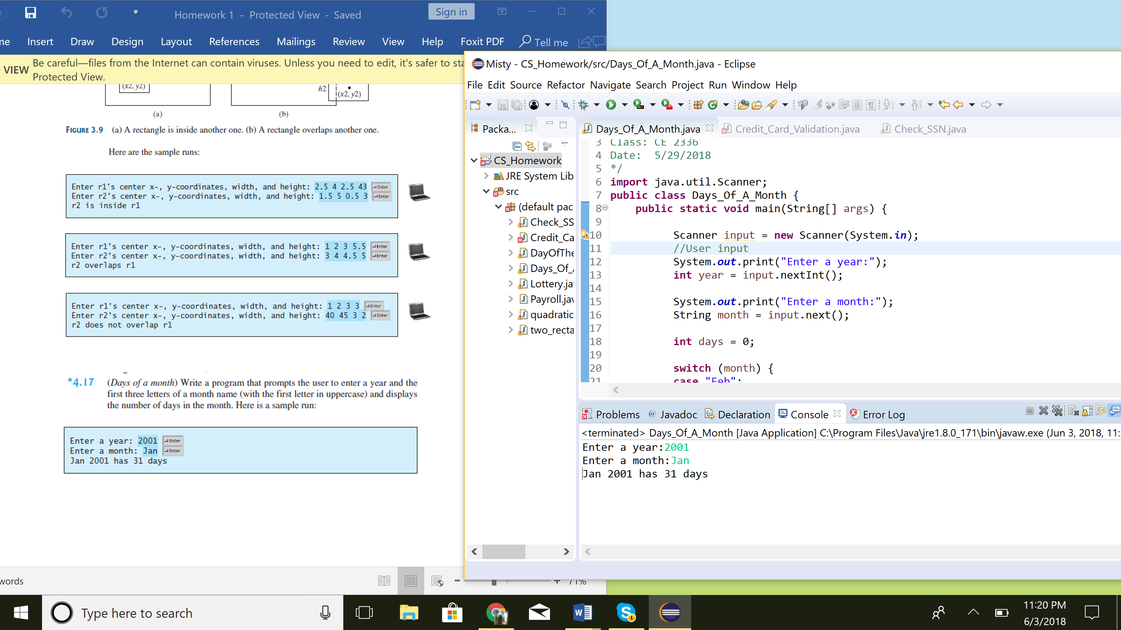

1. Prompt user for year and month abbreviation.
   1. Abbreviation for months are 3 letters
2. Use a switch for the months and group the months that have the most and least days
   1. Feb : 28/29 days
      1. Check the year to determine whether it was a leap year or not
   2. Apr/Jun/Sep/Nov : 30 days
   3. Jan/Mar/May/Jul/Aug/Oct/Dec : 31 days
3. Print out the Month, Year and how many days is in that month

**Exercise 4.21: Check SSN**

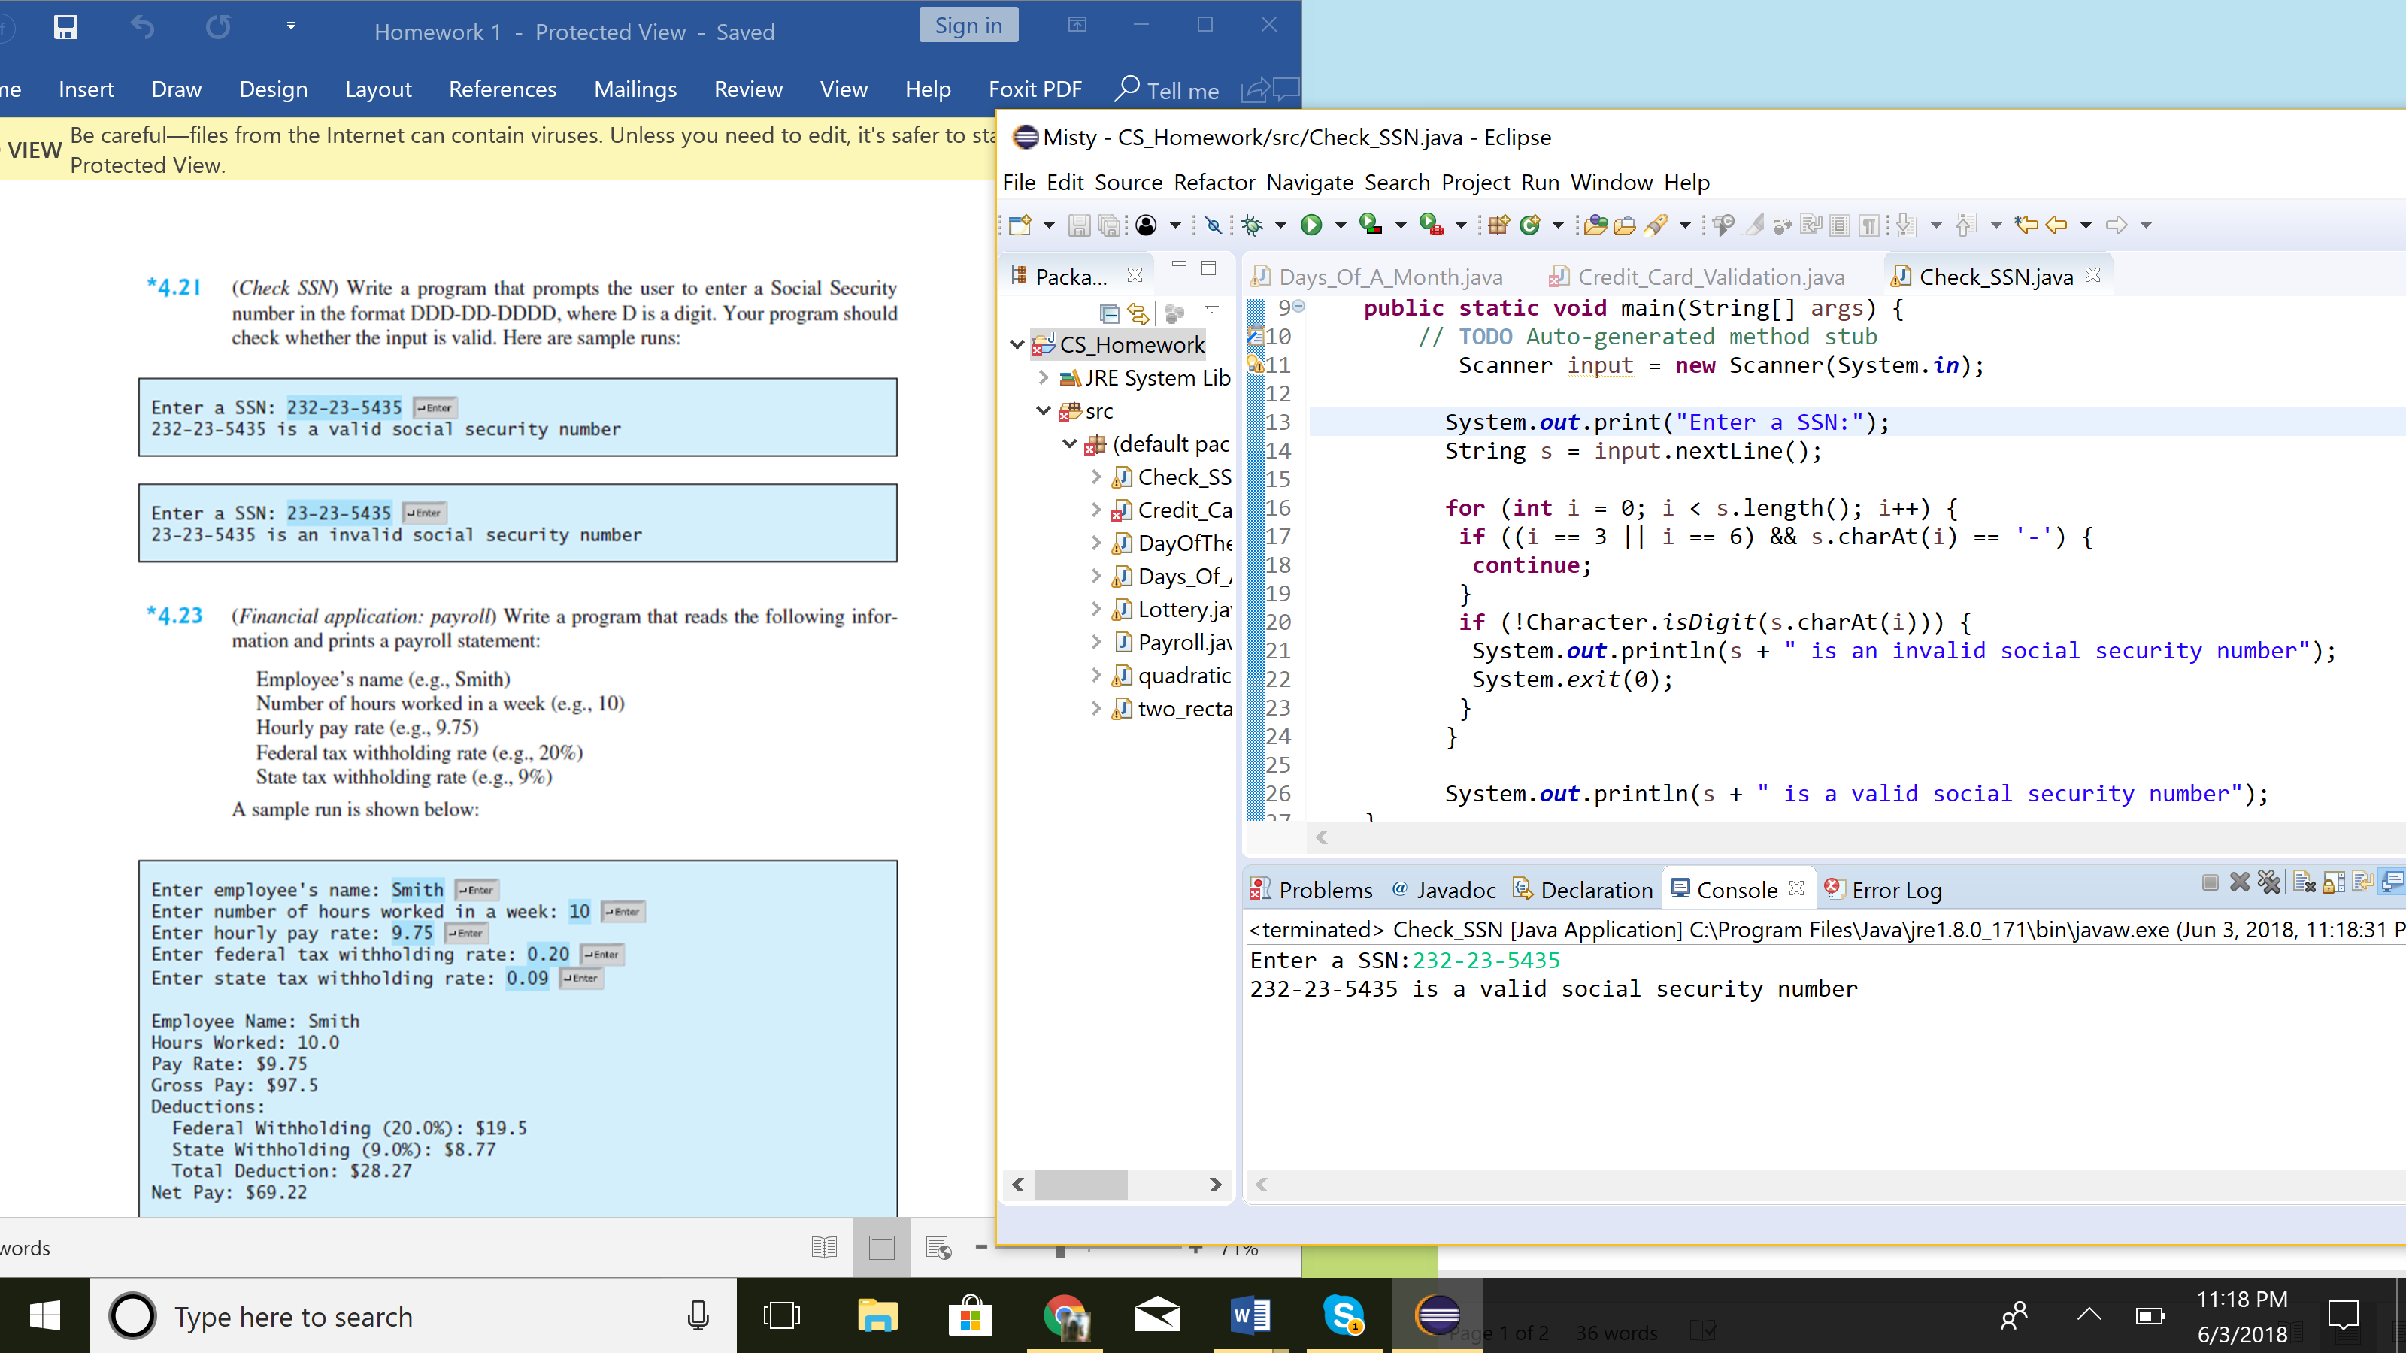

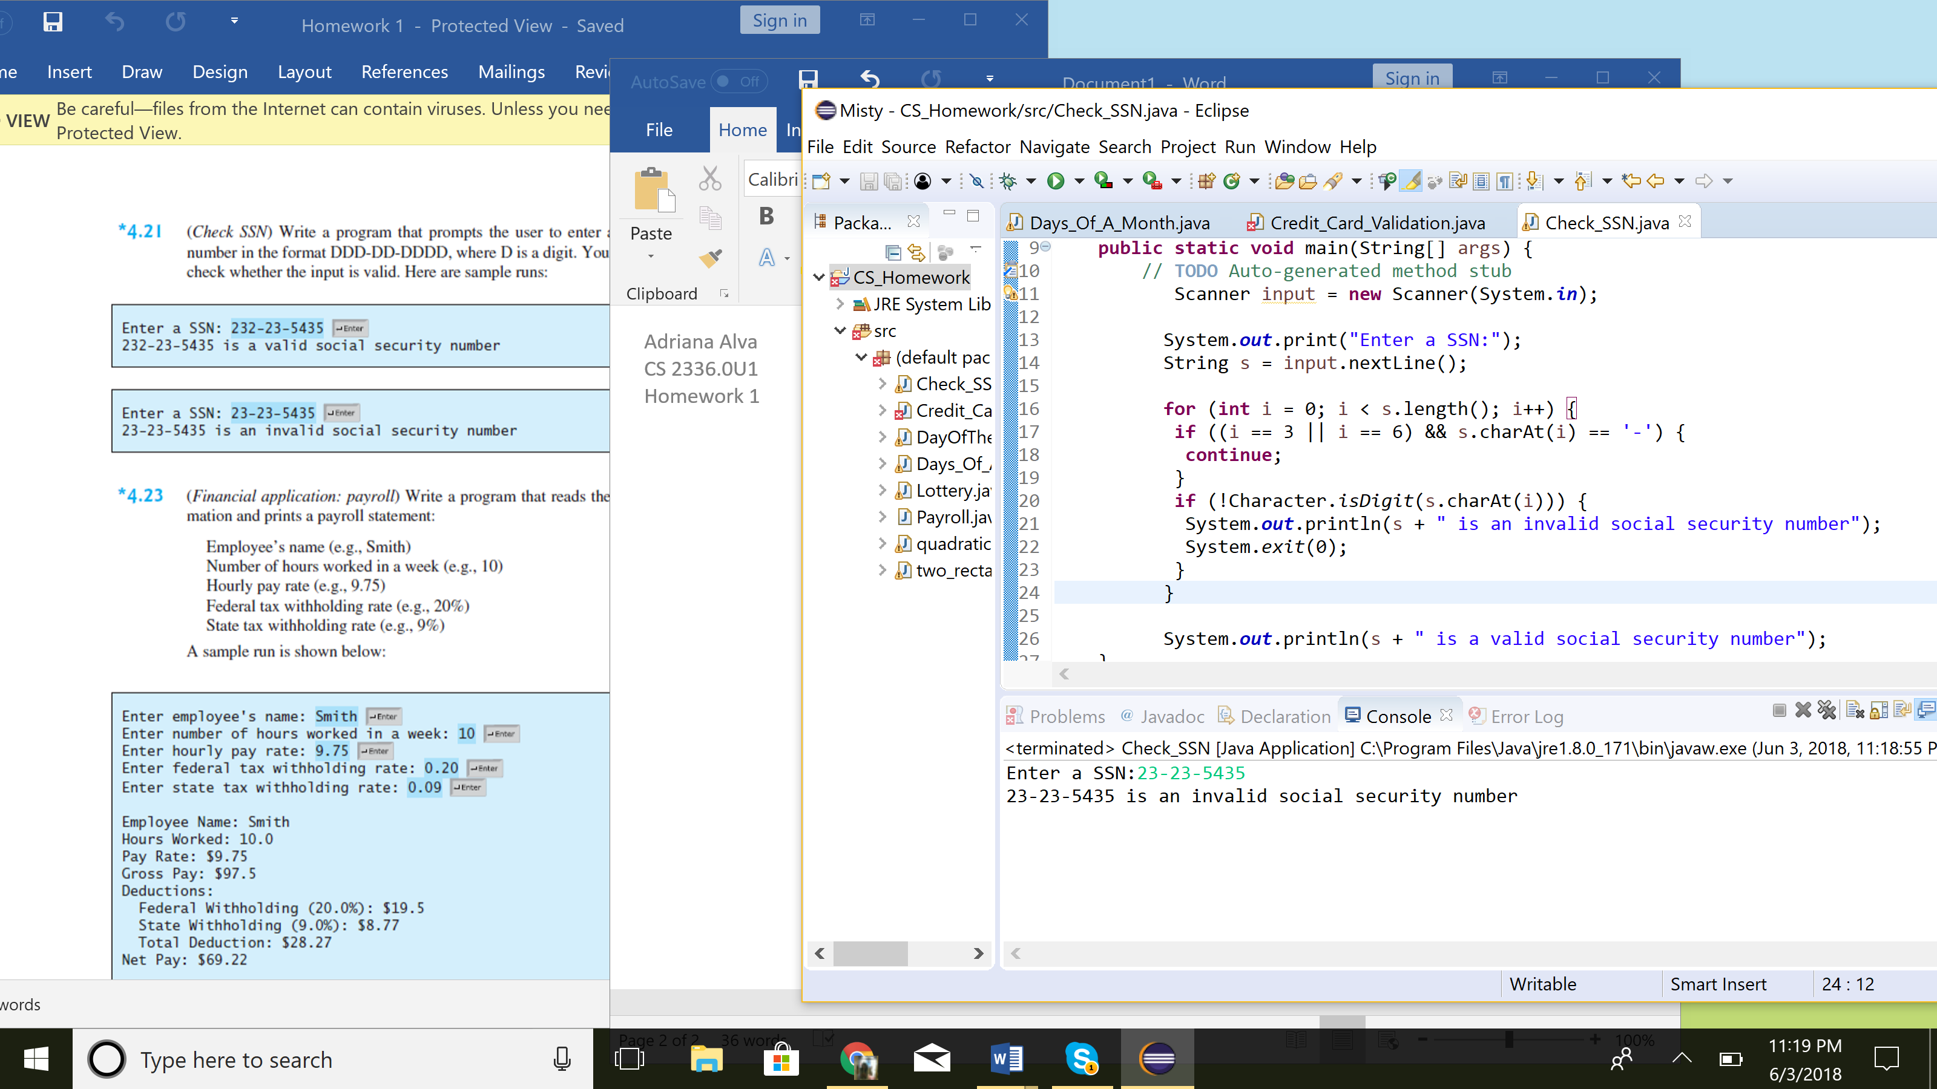

1. User enters SSN in format of DDD-DD-DDDD, D is a digit
2. Check if user input is valid

**Exercise 4.23: Payroll**

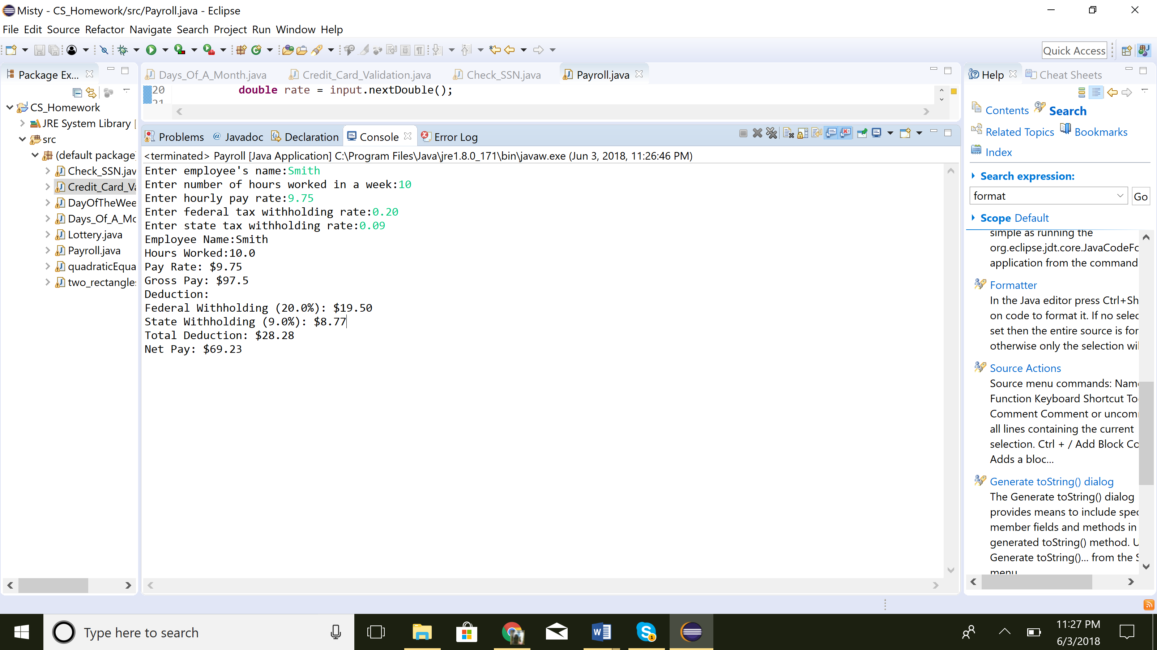

1. No methods are needed
2. Prompt user for all information needed
3. Print payroll statement with desired format

System.***out***.printf("Federal Withholding (%.1f%%): $%.2f\n", fedtax * 100, fedtax * rate * hours);

System.***out***.printf("State Withholding (%.1f%%): $%.2f\n", stax * 100,stax * rate * hours);

System.***out***.printf("Total Deduction: $%.2f\n", (stax + fedtax) * rate* hours);

**Exercise 6.31 : Credit Card Number Validation**

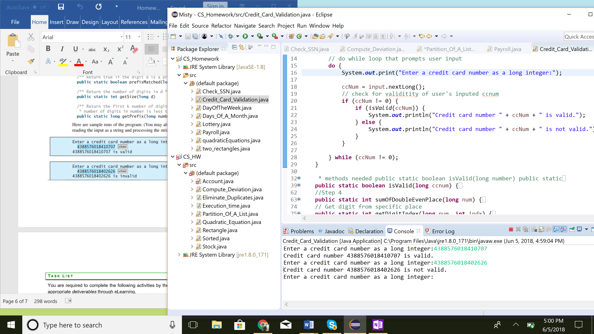

1. Prompt user for cc# and check if it is a valid number
2. cc# has to be entered as a long integer
3. With the first digit, check if it matches that of any credit card company
4. Methods match steps that are used to see if a cc# is valid
5. Methods needed

* public static boolean isValid(long number)
* public staticboolean prefixMatched(long number, int d)
* public static intsumOfOddPlace(long number)
* public static int sumOfDoubleEvenPlace(long number)
* public static int getDigitFromIndex(long number, int index)
* Public static int getDigit(int num)
* public static int getSize(long d)
* public static long getPrefix(long number, int k)

Hint: Credit Card problem is easier to solve if you use a String instead of long.